SS8H5a Explain the establishment of the University of Georgia, Louisville, and the spread of Baptist and Methodist churches.

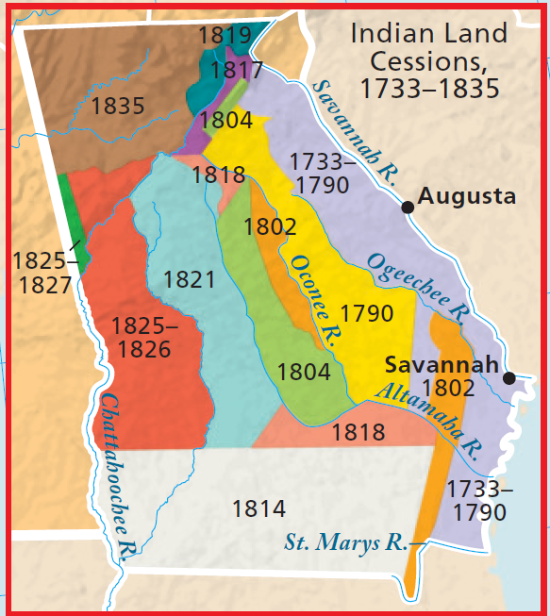
UNIVERSITY of GEORGIA

1785: Federal US government provides money to purchase land for a public university (land grant charter) - Thus becoming the oldest public university in the United States of America. The university was created to improve the knowledge and skills of Georgia citizens in an effort help the economy and improve the standard of living of Georgians

1801: Students (only all-white / all-male) attend classes in the Franklin College building

1918: Women were allowed to attend the university.

1961: Charlayne Hunter and Hamilton Holmes became the first black students to attend the University of Georgia after desegregation of schools

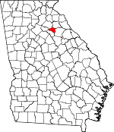

LAND LOTTERY
White males, orphans, and widows were eligible to receive lands west of the Oconee River that became available after the Creek Treaty of Indian Springs and the Cherokee Treaty of New Echota. The map above shows the land lotteries from 1804 -1835 that encouraged white settlement in western and northern Georgia due to the ability to make money from cotton plantations and the discovery of gold.

CAPITAL CITY of LOUISVILLE

Savannah was the first capital because it was the 1st permanent settlement in Georgia. Augusta became the 2nd capital but it was located too far east. So, in 1786, the Georgia legislature decided to build a new city that would serve as the 3rd capital of Georgia and would be centrally located for citizens to travel there. The city was named after King Louis XVI of France for his help in America’s Revolutionary War. Louisville was not a capital city for very long because of the state’s westward expansion due to Indian lands becoming opened for settlers. Milledgeville became the 4th capital in 1807, followed by Atlanta in 1877, the current capital. One of the most memorable events to occur in the capital city of Louisville was the burning of all of the Yazoo Land Fraud records in front of the capitol building in 1796.

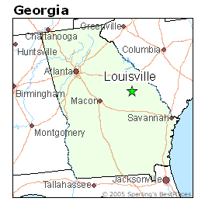

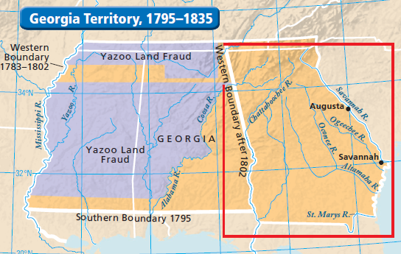

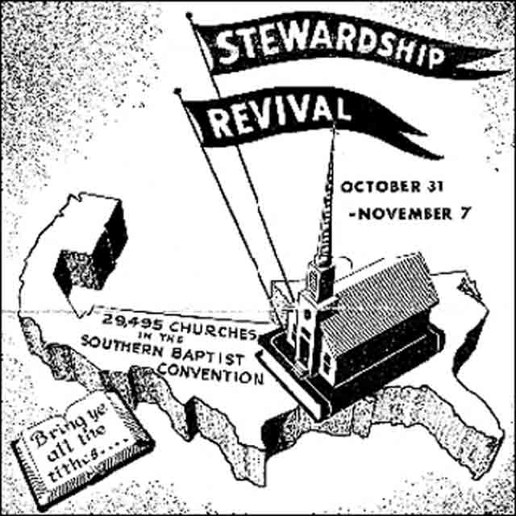
SPREAD of BAPTIST and METHODIST CHURCHES
The Great Revivals are periods of time in American history where there is a renewed focus on religion - personally, socially, and politically.

The Methodist and Baptist denominations (branching off of the Protestant branch) were small at the time, however, the 2nd Great Awakening helped these churches grow in number and spread across the southeast United States. Interest in religion increased during this time period by allowing people to attend large camp meetings called “revivals”, and the southeast region came to be known as The Bible Belt.

Today, religion has a large influence on the culture of the South. Examples include the many churches in each county, blue laws (illegal to sell liquor on Sundays), and fast food chain Chic-fil-A not being open for business on Sunday, to name a few.

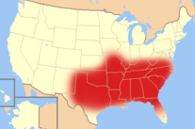

SS8H5b Evaluate the impact of land policies pursued by Georgia; include the headright system, land lotteries, and the Yazoo land fraud.
MAKES
LAWS
INTERPRETS
LAWS
HEADRIGHT SYSTEM
To attract settlers for economic development and political representation in US government, the Georgia government provided land to Americans east of the Oconee River. Each white male counted as a “head” of a family and had the “right” to receive anywhere from 200 – 1,000 acres of land. Farmers and ranchers were able to start up their business. In
1782, most of the land was given to Revolutionary War veterans for their service. If you recall, this is how Elijah Clarke and Austin Dabney received land.

On the map to the left shows how land was distributed from 1733-1835..

YAZOO LAND FRAUD
Four land companies bribed the governor of Georgia and the General Assembly (legislature) to pass a bill to buy large tracts of land near the Yazoo River in Mississippi. The companies bought up to 50 million acres of land for only 1 ½ cents per acre. The companies would then sell the land at much higher prices and share the profits with the legislators. The US government solved the scandal by forcing Georgia to cede (give up) the lands west of the Chattahoochee River in exchange for $1.25 million dollars and a promise to help remove Creek and Cherokee Indians from the Georgia territories. Georgia’s western border is became the Chattahoochee River.

SS8H5c Explain how technological developments, including the cotton gin and railroads, had an impact on Georgia’s growth.
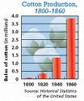
IMPACT OF THE COTTON GIN ON GEORGIA
In 1793, Eli Whitney invented a machine that would make producing cotton much easier and profitable. The production of cotton increased tremendously in the 1800s. The unintended consequence was that white settlers needed more land to produce cotton which led to the removal of Creek Indians in Georgia. In addition, the South became more dependent on slave labor and the plantation system of agriculture dominated the southern states, whereas the northern states were more industrial. This would lead to one of the causes of the American Civil War.

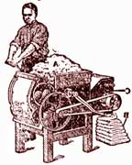

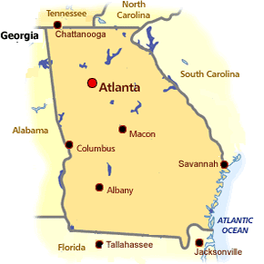
IMPACT OF THE RAILROAD ON GEORGIA
In 1837, during the removal of Cherokee Indians from north Georgia the Western & Atlantic railroad company helped build the city of Terminus (later named Atlanta) where Underground Atlanta is located next to the Coca Cola museum. Atlanta becomes a major transportation hub in the southeast as the railroad transports Georgia agricultural products to the Midwest and Atlantic coast. This helps connect Atlanta to other cities in the state.

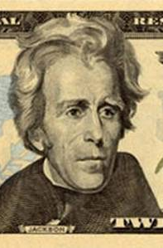

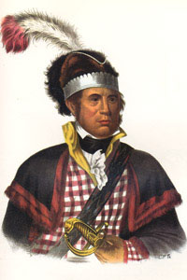
SS8H5d Analyze the events that led to the removal of Creeks and Cherokees; include the roles of Alexander McGillivray, William McIntosh, Sequoyah, John Ross, Dahlonega Gold Rush, Worcester v. Georgia, Andrew Jackson, John Marshall, and the Trail of Tears.
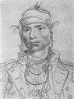
CREEK
NATION

ALEXANDER McGILLIVRAY
Bi-racial Creek Indian chief
during the 1780-90s that fought against white settlement on Creek lands during the Oconee War. He signed the Treaty of New York with President George Washington in 1790 that allowed headright system land to be given to whites east of the Oconee River in exchange for US protection of Creek lands west of the Oconee River.
WILLIAM McINTOSH
Bi-racial Creek Indian chief in the early 1800s that ceded (gave up) Creek lands west of the Oconee River in exchange for private property and $200,000 by signing the Treaty of Indian Springs in 1825. Because he did not get the permission of other Creek tribal chiefs he violated a Creek law whose punishment was death. William McIntosh was dragged from his burning house, shot, and stabbed in the chest for his betrayal to the Creek Nation.

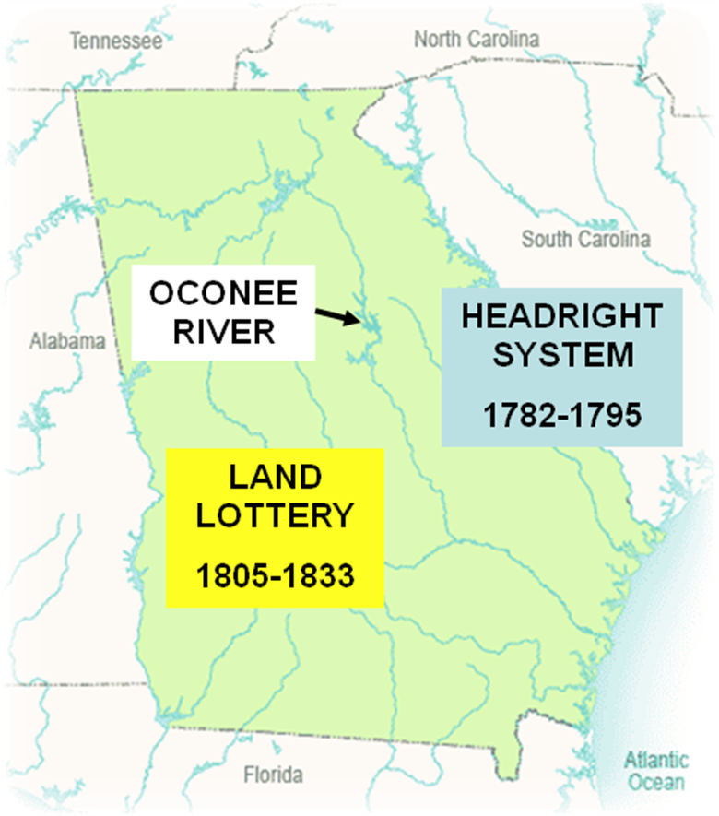

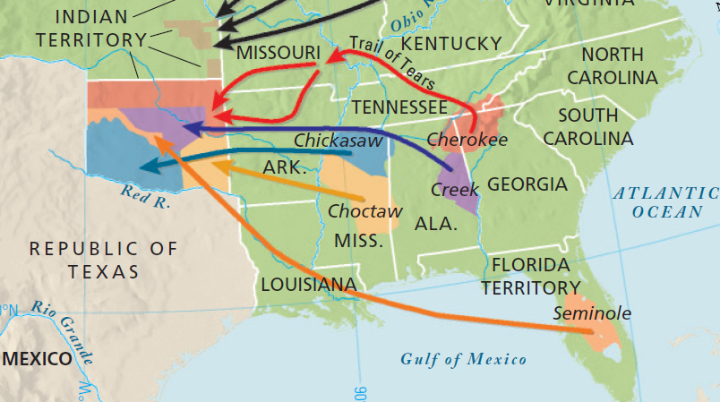
SEQUOYAH
1821 - Created a syllabary-written Cherokee language for Cherokees to be accepted by the white culture. The Cherokee Phoenix newspaper developed as a result.

JOHN ROSS
1827- Chief (president) of the Cherokee Nation until 1866. Refused to leave Georgia after the illegal Treaty of New Echota and survived the Trail of Tears. Oklahoma.

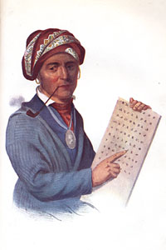
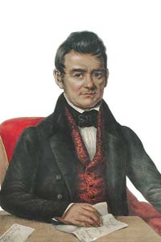

DAHLONEGA GOLD RUSH
In 1828, settlers discovered gold in Cherokee territory in north Georgia (present day Dahlonega). Georgia legislators created the Indian Removal Act in 1830 that paved the way for white settlers to remove the Cherokees from Georgia. In 1835, Georgia held another land lottery and the Cherokees were eventually forced out in an event known as the Trail of Tears.by the US government.
WORCESTER v. GEORGIA
1832 - Sam Worcester was a white missionary the Georgia gov’t arrested by for not having a license to live on Cherokee land. He appealed his case to the Supreme Court which ruled that Georgia acted unconstitutionally and that Georgia laws did not apply in Cherokee lands. Sadly, President Jackson refused to enforce this decision & Cherokees were forced to leave Georgia.
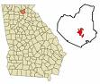



JOHN MARSHALL
Chief Justice of the US Supreme Court that ruled in favor of the Cherokee Indians in the court case Worcester v. Georgia. The ruling was not enforced by the President.

ANDREW JACKSON
1830 - Signed the Indian Removal Act and the Treaty of New Echota that led to the Trail of Tears. Did not enforce (support) the Supreme Court decision Worcester v. Georgia.

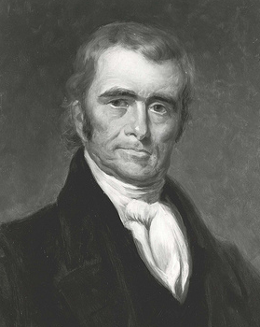

TRAIL OF TEARS
In 1835, a Cherokee chief named Major Ridge signed the Treaty of New Echota with US President Andrew Jackson but without the permission of Cherokee principal chief John Ross. This treaty gave up all Cherokee lands in Georgia in exchange for lands in Oklahoma and 5 million dollars. John Ross and other Cherokees thought the US government would protect Cherokee lands from white settlement because of the Worcester v. Georgia Supreme Court case. Instead, the US Army enforced the 1830 Indian Removal Act and in 1838 Cherokee homes and farms were burned, and the Cherokees were rounded up in concentration camps and forced to migrate to Oklahoma. Many of the Cherokee suffered from cold exposure, disease, and starvation. As a result, approximately 4,000 or 25% of the Cherokee people died on the Trail of Tears. Major Ridge and others Cherokees who signed the Treaty of New Echota were soon executed in Oklahoma by supporters of Cherokee chief John Ross.

UNIVERSITY OF GEORGIA

